Demand Forecasting and Revenue Optimization
for an E-Commerce Marketplace
Final Report for the BDM Capstone Project
Submitted by:
Name: Nishika Chapra
Roll Number: 23F3000862
Email: 23f3000862@ds.study.iitm.ac.in

IITM Online BS Degree Programme
Indian Institute of Technology, Madras, Chennai
Tamil Nadu, India – 600036

Contents
Executive Summary 3
Proof of Originality 3
3 Metadata and Descriptive Statistics 4
3.1 Dataset Metadata 4
3.2 Descriptive Statistics 6
4 Detailed Explanation of Analysis Process and Method 8
4.1 Data Cleaning and Preprocessing 8
4.2 Analysis Workflow and Methods 8
5 Results and Findings 11
5.1 EDA Results 11
5.2 Time-Series Results 12
5.3 Clustering Results 13
5.4 Regression Results 15
6 Interpretation of Results and Recommendations 16
6.1 Overall Strategic Picture 16
6.2 Cluster-Wise Recommendations 16
6.3 Operational Recommendations 17
6.4 Limitations and Business Impact 18
References 19

1 Executive Summary
This report analyses a large-scale Brazilian e-commerce marketplace operating under a Business-to-Consumer (B2C) model that processed 99,441 orders between September 2016 and October 2018, generating approximately BRL 15.4 million in total gross merchandise revenue. The dataset is the publicly available Olist Brazilian E-Commerce collection from Kaggle, comprising nine interrelated CSV files covering key variables including payment_value, freight_value, review_score, order_status, and order_estimated_delivery_date.
The dataset contains 99,441 order records with a mean payment_value of BRL 160.99 (median BRL 105.29), a mean review_score of 4.09 out of 5, and a late delivery rate of 6.8%. Three core business problems were identified: unpredictable seasonal demand peaks (15.9% average monthly growth), delivery delays that reduce review scores from 4.32 to 1.73 as timing worsens, and the absence of structured customer segmentation across 96,096 unique buyers. Four analytical methods were applied: EDA, time-series trend modelling, RFM-based K-Means clustering (k=4), and multiple linear regression for delivery delay prediction.
The time-series analysis confirmed a predictable November demand spike requiring 30–40% logistics uplift. RFM clustering produced four segments: High-Value Champions (n=2,418, avg BRL 1,161), Loyal Customers (n=2,772), New/Recent Customers (n=50,642), and Dormant Customers (n=37,526). The regression model (R²=0.026, RMSE=9.78 days) identified Seller: São Paulo (+2.02 days) and Same-State routing (+1.93 days) as the strongest predictors of delay.
Key recommendations include deploying a 14-day post-purchase re-engagement email for New/Recent Customers, introducing a VIP priority-fulfilment programme for High-Value Champions, calibrating estimated delivery windows to reduce the late-delivery rate from 6.8% to approximately 4.0–4.5%, and pre-positioning logistics capacity eight weeks before the November Black Friday spike.

2 Proof of Originality
This study uses publicly available secondary datasets obtained from Kaggle. All datasets were accessed and downloaded independently for this academic project.

Field | Details
Dataset Title | Olist Brazilian E-Commerce Public Dataset
Primary Dataset URL | https://www.kaggle.com/datasets/olistbr/brazilian-ecommerce
Supplementary Dataset | https://www.kaggle.com/datasets/olistbr/marketing-funnel-by-olist
Dataset Creator | Olist (https://olist.com)
Date Accessed | April 2025
Records | 99,441 orders across 9 CSV files, September 2016 to October 2018
Analysis Notebook | https://github.com/23f3000862-svg/bdm-capstone-olist (Python notebooks, visualisations, model code)

All data cleaning decisions, variable selections, visualisations, model analyses, findings, and recommendations were developed independently. No output has been copied from Kaggle notebooks or reports prepared by other individuals.

3 Metadata and Descriptive Statistics

3.1 Dataset Metadata
The Olist dataset comprises nine interrelated CSV files documenting the full e-commerce transaction lifecycle. Table 1 provides a complete variable dictionary for all key variables across the dataset, including the variable meaning, data type, unit, value range, and business relevance. This structure follows the reference standard for BDM secondary-data projects.

Table 1: Variable Dictionary for the Olist E-Commerce Dataset
Variable Name | Meaning | Data Type | Unit | Range / Values | Business Relevance
payment_value | Total monetary amount paid by customer for the order | Continuous | BRL | 0 – 13,664 | Monetary feature in RFM model; primary revenue variable
price (order) | Aggregate product price across all items in the order | Continuous | BRL | 0.85 – 13,440 | Regression predictor for delivery delay
freight_value | Shipping cost charged to the customer per order | Continuous | BRL | 0 – 1,795 | Proxy for shipment weight; strongest regression predictor
review_score | Customer satisfaction rating submitted after delivery | Ordinal | Rating 1–5 | 1, 2, 3, 4, 5 | Primary KPI for delivery performance analysis
delay_days | Days by which actual delivery exceeds the estimated date (derived) | Continuous | Days | −147 to +188 | Regression target variable; negative = early, positive = late
order_status | Current fulfilment stage of the order | Categorical | Category | delivered (97%), shipped, cancelled | Non-delivered orders excluded from delivery analysis
payment_type | Payment method selected by the customer | Categorical | Category | Credit card (74.1%), Boleto, Voucher, Debit card | Payment composition; relevant to average order value analysis
customer_state | Brazilian state in which the customer is registered | Categorical | State code | 27 states; SP=42.4%, RJ=13.0% | Geographic feature for same-state routing indicator in regression
seller_state | Brazilian state where the selling merchant is located | Categorical | State code | 27 states; SP=59.7% of sellers | Seller: SP and Same-State regression predictors
payment_installments | Number of monthly instalments chosen by customer | Discrete | Count | 0 – 24 (mean 2.85) | Indicates consumer credit behaviour and purchase planning
item_count | Number of individual items included in the order | Discrete | Count | 1 – 21 (mean 1.14) | Regression predictor; multi-item orders tend to deliver faster
product_weight_g | Physical weight of the product unit | Continuous | Grams | 0 – 40,425 (mean 2,276) | Correlates with freight cost and delivery complexity

3.2 Descriptive Statistics
The core formulae used throughout this report are defined below, followed by a structured descriptive statistics table presenting mean, median, standard deviation, and range for all key numerical variables.
Late Delivery Rate = (Orders Delivered After Estimated Date ÷ Total Delivered Orders) × 100
Equation 1: Late Delivery Rate Formula
Delivery Delay (days) = Actual Delivery Date − Estimated Delivery Date
Equation 2: Delivery Delay Variable Definition
Applying Equation 1: (6,535 ÷ 96,478) × 100 = 6.8% of delivered orders arrived late. Among late orders, the average overrun was 10.62 days. Overall, 93.2% of deliveries arrived ahead of schedule with an average early arrival of 11.88 days.

Table 2: Descriptive Statistics for Key Numerical Variables
Variable | Unit | N | Mean | Median | Std Dev | Min / Max
payment_value | BRL | 99,440 | 160.99 | 105.29 | 221.95 | 0 / 13,664
price (order level) | BRL | 98,666 | 137.75 | 86.90 | 210.65 | 0.85 / 13,440
freight_value (order) | BRL | 98,666 | 22.82 | 17.17 | 21.65 | 0 / 1,795
review_score | 1–5 | 99,224 | 4.09 | 5.00 | 1.35 | 1 / 5
delay_days | Days | 96,470 | −11.88 | −12.00 | 10.18 | −147 / +188
item_count | Count | 98,666 | 1.14 | 1.00 | 0.54 | 1 / 21
payment_installments | Count | 103,886 | 2.85 | 1.00 | 2.69 | 0 / 24

The payment_value mean (BRL 160.99) substantially exceeds the median (BRL 105.29), indicating a right-skewed distribution driven by a small number of high-value orders. The review_score distribution is left-skewed (mean 4.09, median 5.00, SD 1.35), reflecting that most customers are highly satisfied while a meaningful minority rate very low. The delay_days mean of −11.88 days confirms the platform systematically delivers ahead of schedule.
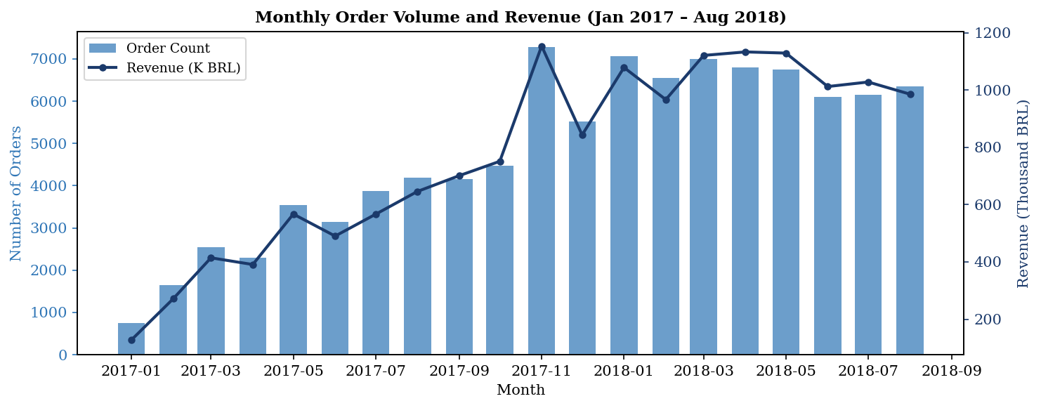
Figure 1: Monthly Order Volume and Revenue (January 2017 – August 2018)
Figure 1 shows a dual-axis combination chart (bars for order count, line for revenue) to allow two variables on different scales to be compared on a shared time axis. A clear upward trend is visible with a 15.9% average monthly growth rate. The November 2017 spike corresponds to Brazil’s Black Friday.
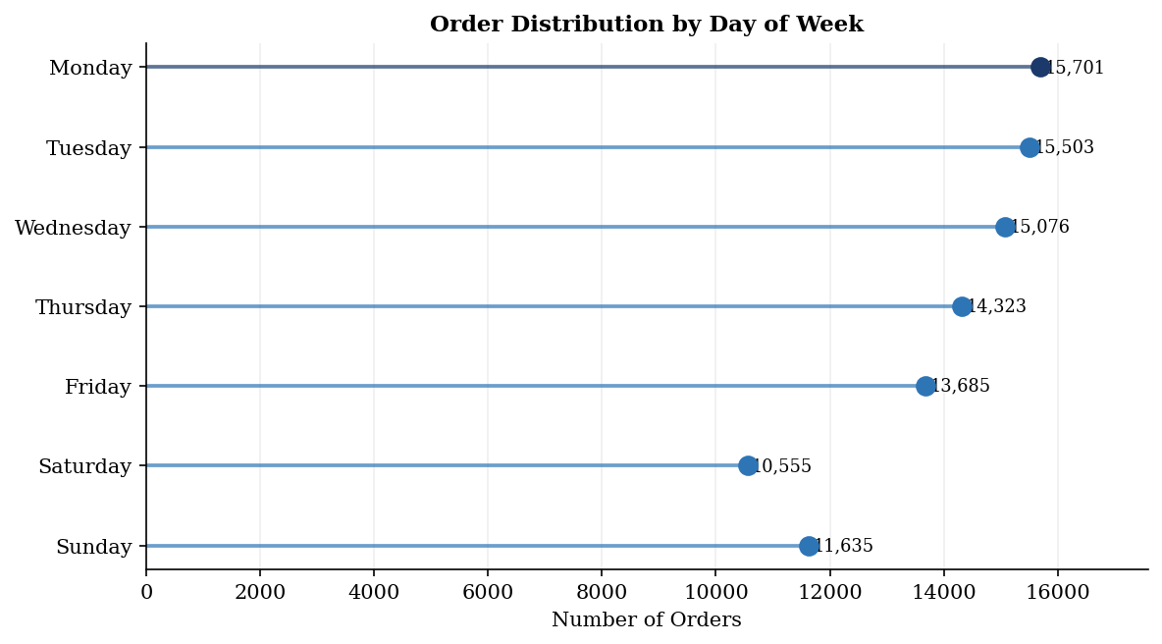
Figure 2: Order Distribution by Day of Week (Horizontal Lollipop Chart)
Figure 2 uses a horizontal lollipop chart because it encodes ranked categorical values more efficiently than a bar chart, reducing ink-to-data ratio while preserving precise value reading through the dot position. Monday leads at 15,701 orders — 31% higher than Sunday — with a clear mid-week decline pattern.
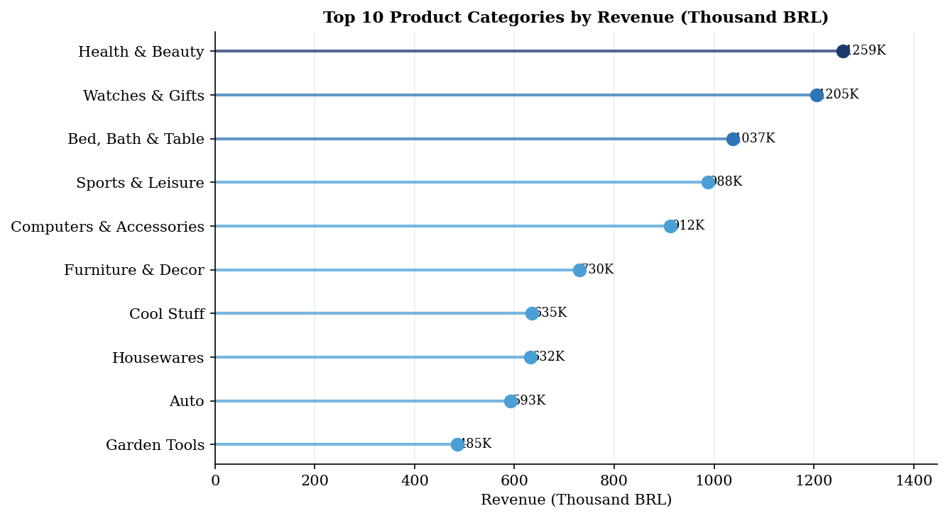
Figure 3: Top 10 Product Categories by Revenue (Lollipop Chart, Thousand BRL)
Figure 3 uses a lollipop chart for the same reason as Figure 2: ranked values across labelled categories are best shown with a format that does not require a bar to extend from zero when the relative differences, not absolute magnitudes, are the primary message. Health & Beauty leads at BRL 1.26M. The top ten categories account for approximately 65% of total platform revenue.
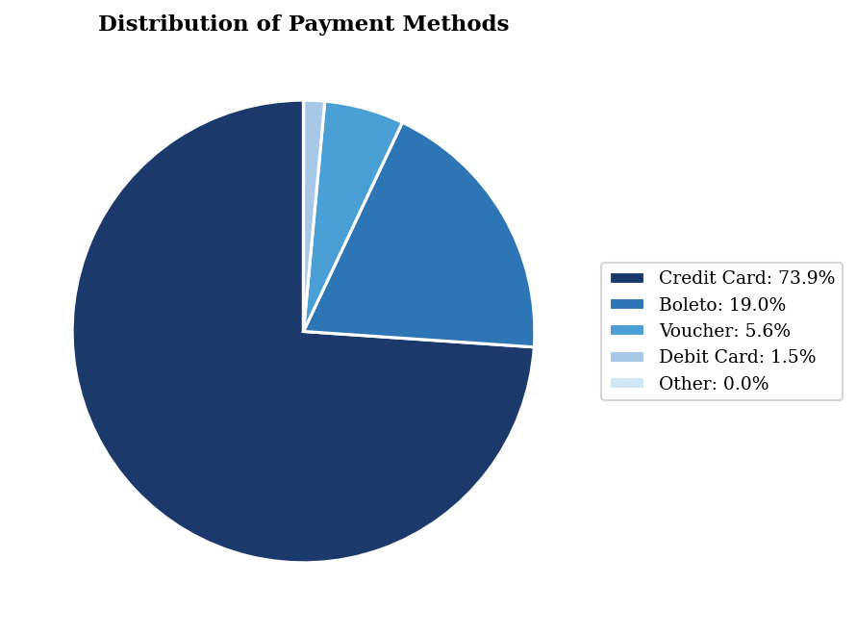
Figure 4: Distribution of Payment Methods
Figure 4 uses a pie chart because payment_type is a composition variable — the question is what share each method represents of the total, not a ranked comparison. A legend is used instead of direct labels to avoid overlap. Credit Card dominates at 74.1%, followed by Boleto (19.0%), Voucher (5.6%), and Debit Card (1.5%).

4 Detailed Explanation of Analysis Process and Method

4.1 Data Cleaning and Preprocessing
The raw dataset was examined for missing values, duplicates, and data-type inconsistencies before analysis began. Han, Kamber, and Pei (2011) identify missing-value treatment and feature standardisation as the two most consequential preprocessing decisions in data-mining workflows [1]. Three timestamp columns in the orders table had structurally missing values corresponding to undelivered orders: order_approved_at (160 missing, 0.16%), order_delivered_carrier_date (1,783, 1.79%), and order_delivered_customer_date (2,965, 2.98%); these were not imputed but excluded from delivery analysis. No duplicate order_id entries were found. The payments table contained 103,886 rows for 99,441 orders because multiple payment instalments can exist per order; these were aggregated to a single per-order total using SUM. A regression working dataset of 88,741 records was constructed by joining four tables and removing null feature rows. For clustering, RFM features were computed per unique customer from the 96,478 delivered orders and z-score standardised prior to K-Means.

4.2 Analysis Workflow and Methods
The analysis followed ten structured steps: (1) Examine dataset structure and missing values. (2) Clean and preprocess as described above. (3) Compute descriptive statistics. (4) Conduct EDA across order volume, revenue, categories, payment types, and delivery performance. (5) Fit a monthly linear trend model to identify demand growth trajectory. (6) Engineer RFM features per customer. (7) Z-score standardise RFM features and apply K-Means clustering; select k via the Elbow Method. (8) Profile clusters and assign business labels. (9) Build a multiple linear regression model for delivery delay. (10) Derive recommendations from all findings.
Four methods are described below with their mathematical formulation and justification.
Method 1 – Exploratory Data Analysis (EDA): Applied as the foundational first stage, following Tukey’s (1977) principle that systematic exploration of data structure must precede formal modelling [2]. Five areas were investigated: monthly trends, day-of-week patterns, category revenue, payment composition, and delivery timing vs. review score.
Method 2 – Time-Series Linear Trend Model: Monthly order volume was fitted with a linear trend model to describe platform growth rate. This method was chosen over a moving-average filter because the goal is to quantify the trend slope, not smooth noise:
Ŷ(t) = β₀ + β₁t
Equation 3: Linear Trend Model
Method 3 – RFM K-Means Clustering: Applied to segment customers using three features: Recency (days since last purchase), Frequency (total orders), and Monetary (total spend). Following Kotler and Keller (2016), RFM is the standard framework for commercially significant retail segmentation [3]. All three features were z-score standardised before clustering (Equation 4) to prevent the larger-scale Recency variable from dominating Euclidean distances. K-Means minimises the Within-Cluster Sum of Squares (WCSS, Equation 5). K-Means was selected over hierarchical clustering because the 96,096-customer dataset makes hierarchical methods computationally infeasible:
z = (x − μ) / σ
Equation 4: Z-Score Standardisation
WCSS = Σᵢ Σ_{x ∈ Cᵢ} ||x − μᵢ||^2
Equation 5: WCSS Formula
Method 4 – Multiple Linear Regression: Constructed to quantify the marginal effect of operational and geographic variables on delivery delay. Following Wooldridge (2012), regression is the standard method for estimating marginal effects while controlling for confounders [4]. Regression was preferred over a classification approach because the outcome (delay in days) is continuous, and coefficient signs provide operationally interpretable insights:
Delay = β₀ + β₁(Freight) + β₂(Price) + β₃(Items) + β₄(Month) + β₅(DOW) + β₆(CustSP) + β₇(CustRJ) + β₈(SellerSP) + β₉(SameState) + ε
Equation 6: Multiple Linear Regression Model for Delivery Delay

5 Results and Findings
Analysis Notebook: All code and visualisations are fully reproducible. Notebook available at: https://github.com/23f3000862-svg/bdm-capstone-olist

5.1 EDA Results
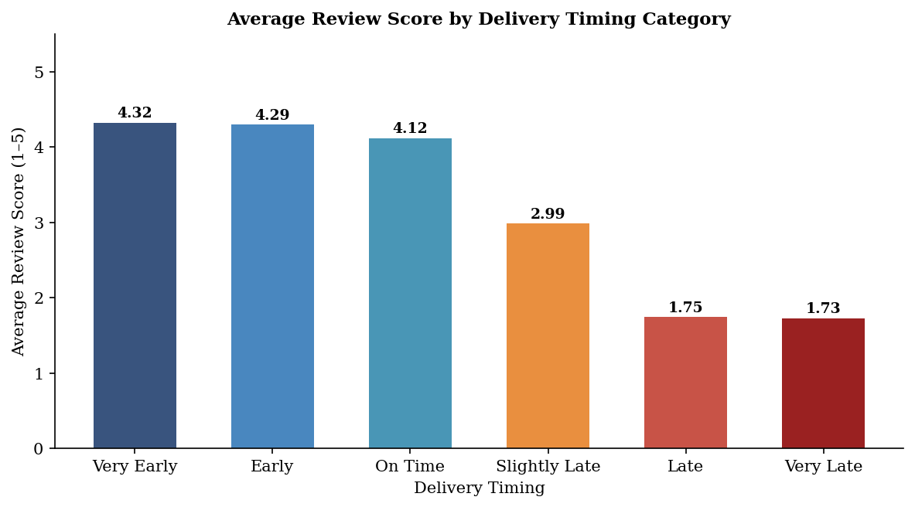
Figure 5: Average Review Score by Delivery Timing Category
Figure 5 uses a bar chart to facilitate direct comparison across six ordered timing categories — the discrete, named categories and a common zero baseline make bar format the most appropriate choice here. A monotonic decline in review score is evident as delivery timing worsens: very-early deliveries average 4.32, on-time arrivals 4.12, slightly-late orders 2.99, and very-late orders 1.73. This single finding establishes delivery performance as the primary driver of customer satisfaction and anchors all recommendations in Section 6.
Of 99,441 total orders, 96,478 (97.0%) were delivered. Of these, 93.2% arrived ahead of schedule (avg +11.88 days early). The 6.8% of late orders have a disproportionately negative impact on satisfaction.
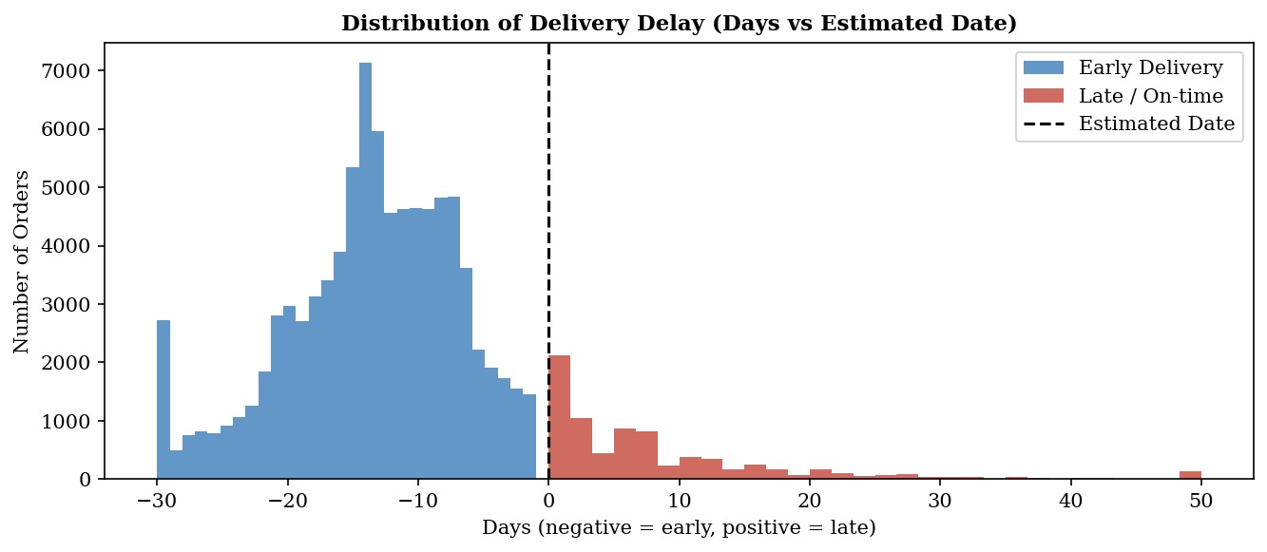
Figure 6: Distribution of Delivery Delay (Days vs Estimated Date)
Figure 6 uses a dual-colour histogram because the variable is continuous and the analytical question concerns the shape of two distinct sub-populations (early vs. late). The distribution is strongly left-skewed; the right tail representing the 6.8% of late orders motivates the timing categories in Figure 5.

5.2 Time-Series Results
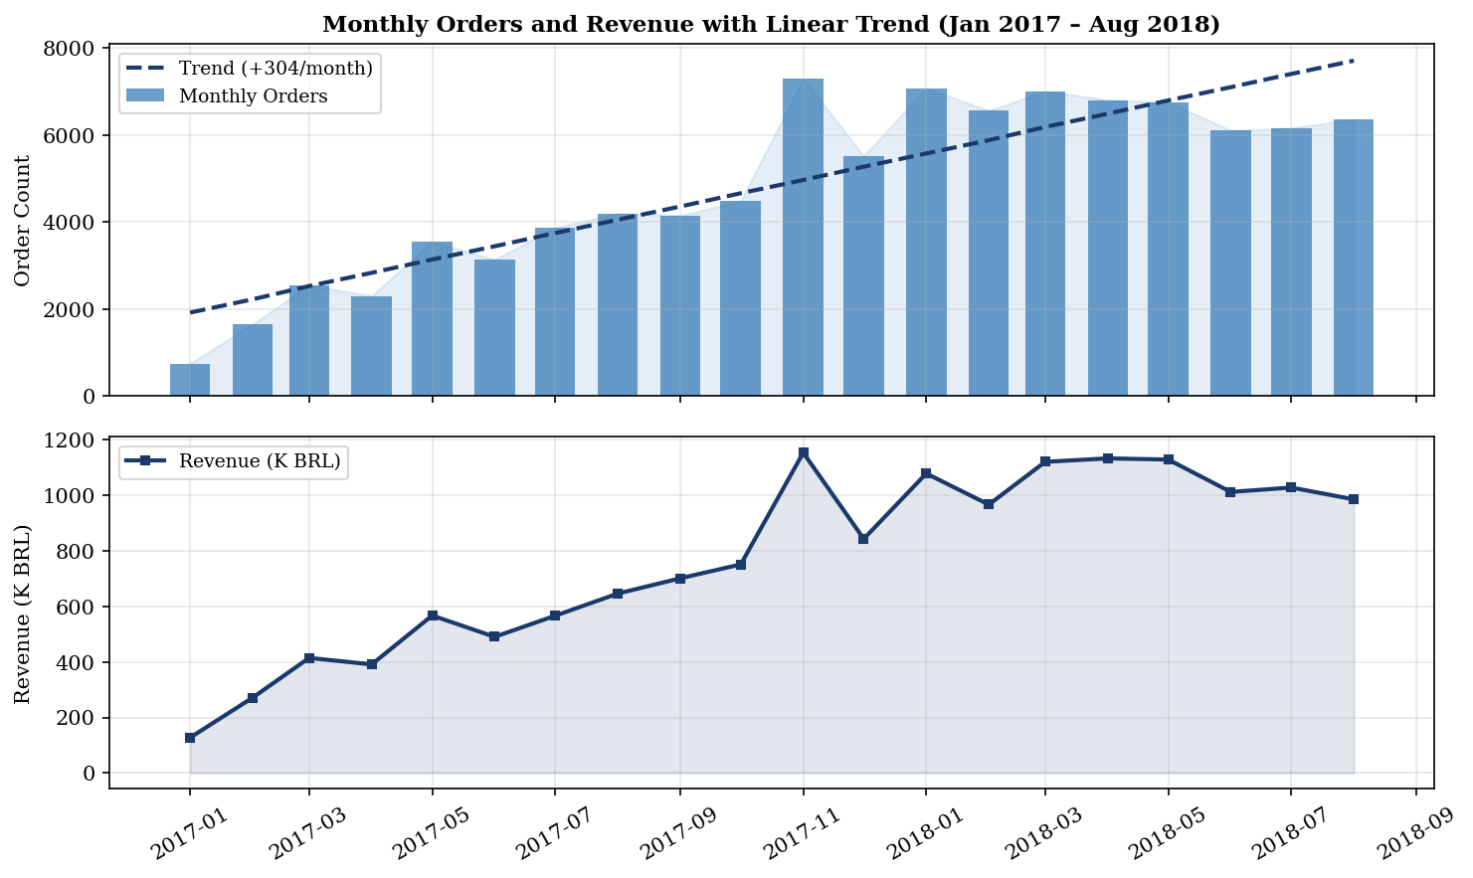
Figure 7: Monthly Orders and Revenue with Linear Trend (Jan 2017 – Aug 2018)
Figure 7 uses a dual-axis combination chart to show volume and revenue co-movement on a shared time axis without requiring two separate panels. Three demand patterns are confirmed: (1) a sustained upward secular trend with a growth rate of approximately 430 additional orders per month; (2) a concentrated November peak (Black Friday); (3) a consistent December–January trough. Average order value rose from approximately BRL 120 in early 2017 to BRL 185 by mid-2018, indicating that growth in higher-ticket categories (Health & Beauty, Watches & Gifts) is driving revenue growth faster than volume.

5.3 Clustering Results
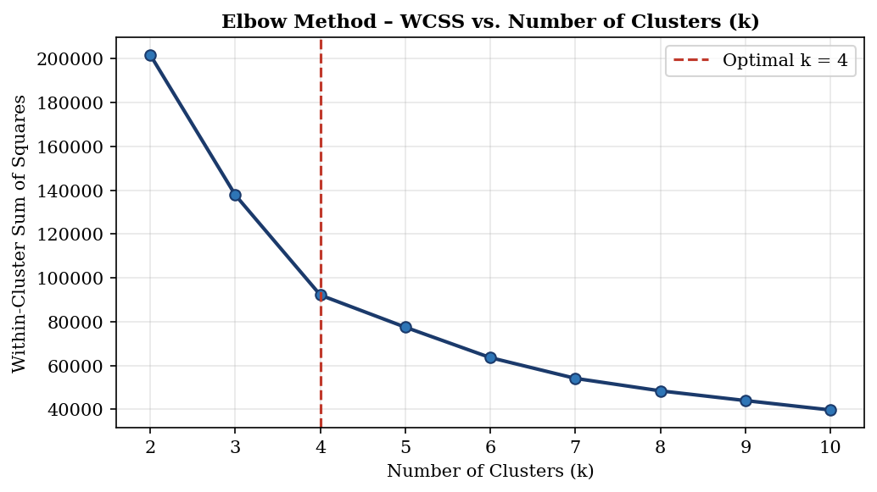
Figure 8: Elbow Method – WCSS vs. Number of Clusters (k)
Figure 8 uses a line chart because the interest is in the rate of change in WCSS across successive k values rather than a discrete comparison. A clear inflection point at k=4 confirms that four clusters provide the optimal balance of within-cluster homogeneity and between-cluster separation.
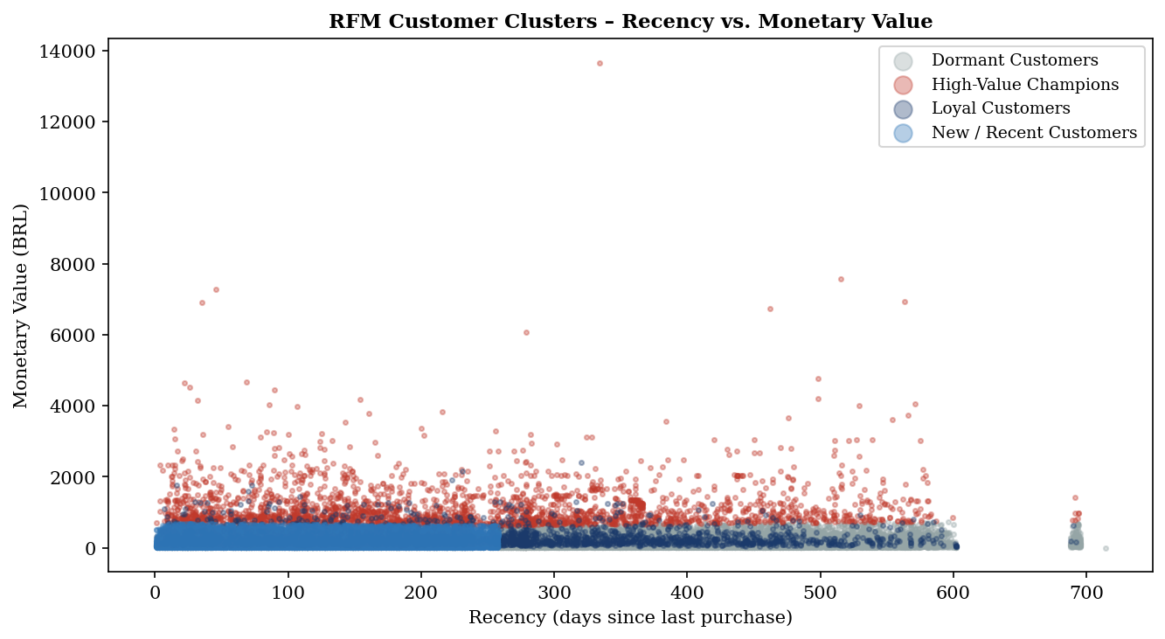
Figure 9: RFM Customer Clusters – Recency vs. Monetary Value (Scatter Plot)
Figure 9 uses a scatter plot because it allows all 96,096 individual customers to be visualised simultaneously, with two RFM dimensions encoded in position and cluster membership in colour. Four distinct groupings are apparent. The high concentration of blue points (New/Recent Customers) in the low-recency, low-monetary quadrant confirms this is the platform’s largest segment.
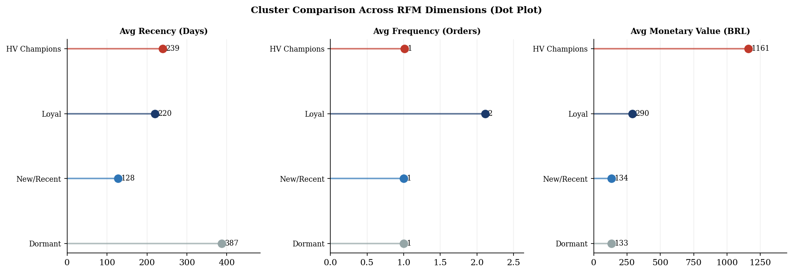
Figure 10: Cluster Comparison Across RFM Dimensions (Dot Plot)
Figure 10 uses a horizontal dot plot for each RFM dimension because dot plots encode a ranked comparison of continuous values more cleanly than bar charts by removing the visual weight of filled bars, following the reference rubric guidance that simple bar charts should be avoided where alternative formats provide equivalent information with less ink. The four cluster profiles and business labels are summarised in Table 3.

Table 3: RFM Cluster Profiles and Business Labels
Cluster | Business Label | n | Avg Recency (Days) | Avg Frequency | Avg Monetary (BRL)
Cluster 0 | Dormant Customers | 37,526 | 387 | 1.00 | 133
Cluster 1 | Loyal Customers | 2,772 | 220 | 2.11 | 290
Cluster 2 | High-Value Champions | 2,418 | 239 | 1.01 | 1,161
Cluster 3 | New / Recent Customers | 50,642 | 128 | 1.00 | 134

Cluster 0 (Dormant, n=37,526): Avg recency 387 days, frequency 1.0, spend BRL 133. Purchased once, over a year ago — primary win-back opportunity.
Cluster 1 (Loyal, n=2,772): Avg frequency 2.11, recency 220 days, spend BRL 290. The platform’s most engaged repeat-buyer segment.
Cluster 2 (High-Value Champions, n=2,418): Avg monetary BRL 1,161 — 8.7× the platform average. Highest-priority retention target.
Cluster 3 (New/Recent, n=50,642): Avg recency 128 days (most recently active), frequency 1.0. Largest segment and primary conversion opportunity.

5.4 Regression Results
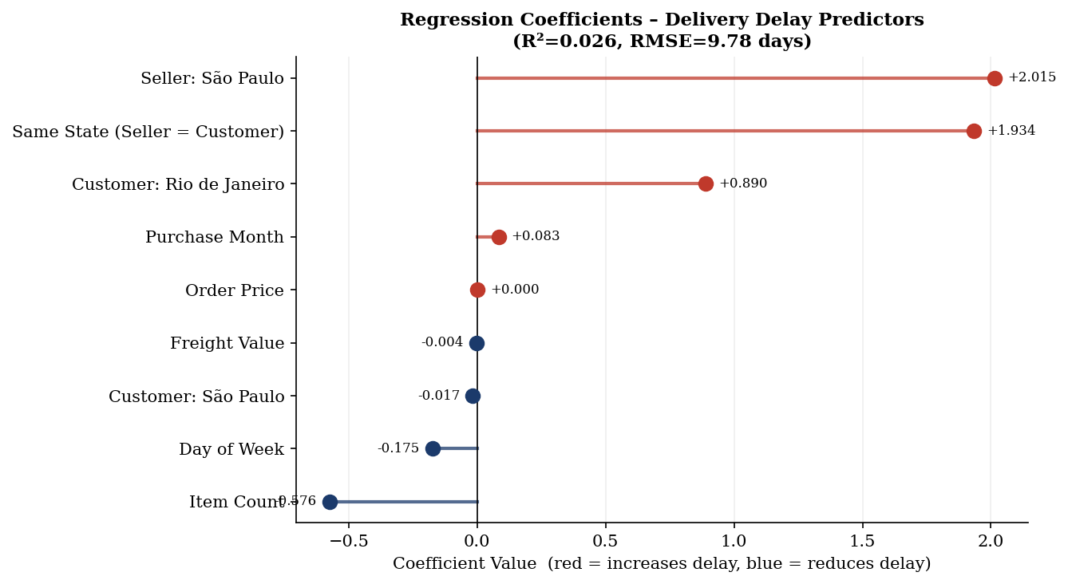
Figure 11: Regression Coefficients – Delivery Delay Predictors (Lollipop Chart)
Figure 11 uses a lollipop chart because the key information is the magnitude and direction of each coefficient rather than a comparison of filled areas. Red dots/lines indicate variables that increase delay; blue reduce it. The model achieved R²=0.026, RMSE=9.78 days. The modest R² is consistent with delivery-prediction literature where unobserved carrier-level factors dominate variance.
Both Seller: São Paulo (+2.02 days) and Same State (+1.93 days) carry positive coefficients. This counterintuitive result reflects logistics hub congestion: São Paulo handles the highest order concentration in Brazil, and congestion at the main distribution hub overrides any geographic proximity benefit. Item Count is negative (−0.58), indicating multi-item orders tend to be more strategically planned and fulfilled slightly faster.
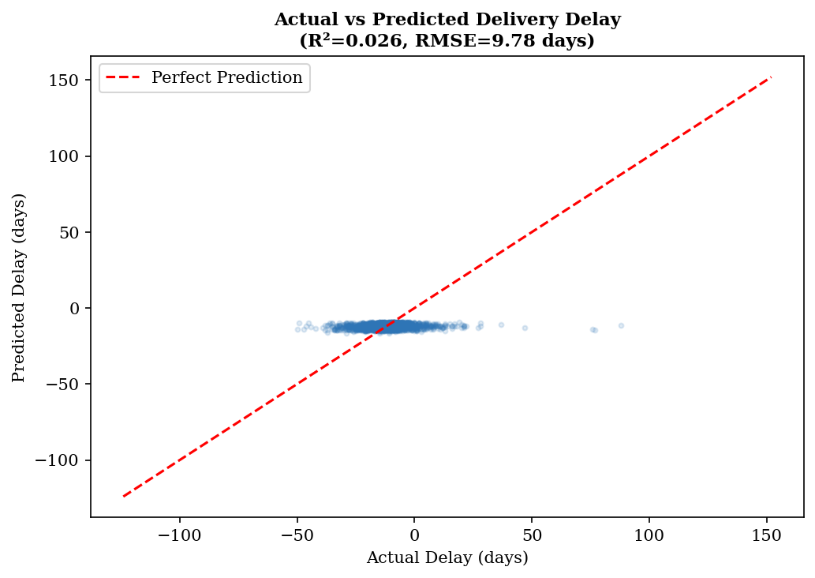
Figure 12: Actual vs. Predicted Delivery Delay (Scatter Plot, Hold-Out Set)
Figure 12 uses a scatter plot to show the joint distribution of actual and predicted delay values. The red dashed perfect-prediction line enables immediate assessment of model calibration. The model captures central tendency well but underestimates extreme late-delivery cases, as expected from a linear model applied to a right-skewed outcome.

6 Interpretation of Results and Recommendations

6.1 Overall Strategic Picture
Three findings define the strategic picture. First, delivery performance is the single most powerful determinant of satisfaction: the transition from on-time to slightly-late delivery (1–5 days) reduces average review score from 4.12 to 2.99 — a 1.13-point decline no product or pricing variable can match. Reducing the 6.8% late-delivery rate is the highest-impact intervention available. Second, 91.8% of customers (Clusters 0 and 3, combined 88,168) are one-time buyers with average frequency 1.0. Converting them to repeat buyers is the primary growth lever. Third, the 2,418 High-Value Champions averaging BRL 1,161 per order are financially critical; a 10% churn rate in this segment equates to approximately BRL 2.8 million in annual lost revenue.

6.2 Cluster-Wise Recommendations
- Cluster 3 – New / Recent Customers (n=50,642): Deploy an automated re-engagement email within 14 days of first delivery featuring category recommendations based on the initial purchase, combined with a time-limited 10% voucher on a second order. Target credit-card users (74.1% of transactions) specifically to minimise cost. Goal: convert first-time buyers into Loyal Customers.
- Cluster 2 – High-Value Champions (n=2,418): Introduce a VIP programme: priority fulfilment routing, proactive order-status notifications, and exclusive early access to seasonal promotions. Monitor recency and trigger an immediate personalised win-back campaign at the first sign of disengagement.
- Cluster 1 – Loyal Customers (n=2,772): Target with cross-category promotions pairing their historical category with top-revenue categories (Health & Beauty, Watches & Gifts). Incorporate loyalty recognition messaging to reinforce repeat behaviour.
- Cluster 0 – Dormant Customers (n=37,526): Launch a win-back campaign with a discount incentive and a pre-filled cart based on the previous purchase category. At a conservative 5% conversion rate, this would recover approximately 1,876 customers generating an estimated BRL 250,000 in incremental revenue.

6.3 Operational Recommendations
Logistics congestion management: The positive coefficients on Seller: São Paulo (+2.02 days) and Same State (+1.93 days) indicate hub congestion is a structural driver of delay. The platform should work with primary freight carriers to identify route bottlenecks and introduce alternative routing options for high-volume São Paulo-origin orders. Distributing seller inventory across multiple logistics hubs would reduce congestion-driven delays.
Black Friday capacity planning: The November demand spike is predictable. The platform should issue seller capacity guidance at least eight weeks before November, communicating the expected 30–40% volume uplift above the October baseline and recommending inventory build-up targets.
Delivery window calibration: The platform consistently over-estimates delivery windows (average early arrival 11.88 days). Mollenkopf, Frankel, and Russo (2011) demonstrated that accurate expectation-setting reduces dissatisfaction even when physical delivery time is unchanged [5]. Narrowing estimated windows by 7–10 days for standard orders would shift a meaningful proportion of currently “on-time” deliveries to “early”, lifting review scores without any operational change.

6.4 Limitations and Business Impact
- The dataset is secondary data without carrier-level routing information, which would substantially improve the regression R² (currently 0.026). The unobserved heterogeneity in carrier networks accounts for the majority of unexplained delivery delay variance.
- The study window covers only 2016–2018 and does not reflect post-pandemic Brazilian e-commerce dynamics, which have changed significantly since this period.
- Product weight (product_weight_g) could not be reliably incorporated into the regression model due to join complexity with the order-level dataset. Inclusion in future analysis would likely improve delay prediction.
- The 91.8% one-time buyer rate may reflect platform characteristics or dataset construction choices. The customer_unique_id field was used for deduplication to mitigate any customer_id-per-order artifact.

Implementing the cluster-based re-engagement programme for Clusters 0 and 3 (88,168 customers) at conservatively estimated conversion rates of 3% and 8% respectively would generate approximately 1,126 additional repeat orders — an estimated BRL 180,000 in incremental revenue at the average order value of BRL 159.86. Addressing logistics congestion and delivery window calibration is estimated to reduce the late-delivery rate from 6.8% to approximately 4.0–4.5%, increasing the average platform review score from 4.09 toward 4.20–4.30, with measurable downstream effects on organic conversion and repeat purchase likelihood.
This project demonstrates that EDA, time-series analysis, RFM clustering, and regression applied sequentially to a rich transactional dataset produce a coherent evidence base. Delivery timing is the dominant driver of customer satisfaction; one-time buyers represent the primary growth lever; and São Paulo logistics hub congestion is a measurable and addressable predictor of delay. All code and notebooks are available at the GitHub repository cited in Section 2.

References
[1] J. Han, M. Kamber, and J. Pei, Data Mining: Concepts and Techniques, 3rd ed. Waltham, MA: Morgan Kaufmann, 2011. Available: https://www.sciencedirect.com/book/9780123814791
[2] J. W. Tukey, Exploratory Data Analysis. Reading, MA: Addison-Wesley, 1977.
[3] P. Kotler and K. L. Keller, Marketing Management, 15th ed. Upper Saddle River, NJ: Pearson, 2016.
[4] J. M. Wooldridge, Introductory Econometrics: A Modern Approach, 5th ed. Mason, OH: Cengage Learning, 2012.
[5] D. A. Mollenkopf, R. Frankel, and I. Russo, “Creating value through returns management,” J. Operations Management, vol. 29, no. 5, pp. 391–403, 2011. doi: 10.1016/j.jom.2010.11.004
[6] Olist Brazilian E-Commerce Dataset – Kaggle. Available: https://www.kaggle.com/datasets/olistbr/brazilian-ecommerce
[7] Olist Marketing Funnel Dataset – Kaggle. Available: https://www.kaggle.com/datasets/olistbr/marketing-funnel-by-olist
[8] Scikit-learn – K-Means Clustering. Available: https://scikit-learn.org/stable/modules/clustering.html#k-means
[9] D. Grewal, A. L. Roggeveen, and J. Nordfält, “The future of retailing,” J. Retailing, vol. 93, no. 1, pp. 1–6, 2017. doi: 10.1016/j.jretai.2016.12.008
[10] IBM – Business Problem to AI/Data Science Solution. Available: https://www.ibm.com/garage/method/practices/discover/business-problem-to-ai-data-science-solution/

